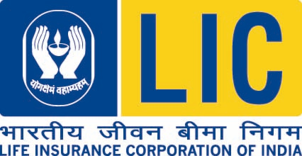

MEMBERSHIP CERTIFICATE
for
Group Term Life Insurance under Chief Minister Advocate Welfare scheme with LIC of India (Advocates who are enrolled with the Bar Council of Delhi (BCD) and are also in the voters list of Delhi)

This is to certify that Shri / Smt /Kum ________________________________________enrolled with “ Bar Council of Delhi” with MembershipNo.________ having Date of birth _______________ residing at (Full Address)__________________________________________________has been covered in Group Term Life Insurance under Chief Minister Advocate Welfare scheme who are in the voters’ list of Delhi from 20.11.2020 to 19.11.2021, under Master Policy No. GINP/103 ________.

Membership No.
LIC Coverage ID
Life Cover (Sum Assured)
Nominee
Relationship
Master Policy Holder

Signature of Issuing Officials
P&GS Unit, 6th Floor, Jeevan
Prakash Building,25 K G Marg
New Delhi-110001

*All Communications should be made through the Nodal Agency Only.

BACK PAGE
Claim Procedure
On happening of the death of the member by any reason, Nominee/ Beneficiary shall approach the authorized Officials of Master Policy Holder/ Nodal agency with claim form and other documents as mentioned below. The authorized Official of MPH/ Nodal agency shall submit the claim forms and other documents duly attested by him/ her to Delhi P&GS Unit, LIC of India, Jeevan Prakash Building, 25 K G Marg, New Delhi-110001.
P&GS Department, Delhi will process the claim as per the rules of the scheme and, on finding the same payable, will transfer the claim amount to the bank account of Nominee/ Beneficiary directly through NEFT/ RTGS on the advice of the MPH/ Nodal Agency.
Documents Required:
- Duly Completed , signed and stamped Claim Form/discharge Form prescribed by the Corporation.
- Original Death certificate issued by appropriate authority
- Proof of Date of Birth.
- Duly attested Copy of Bank Pass Book of Nominee/s /Beneficiary/Claimant OR Original Cancelled Cheque leaf with name of the Nominee/s /Beneficiary/Claimant printed thereon.
- Copy of Aadhar card of Nominee/ Beneficiary/ Appointee.
- Membership certificate issued by Corporation in Original
- Photocopy of Election Photo Identity Card of the member.
- Any other document as required by the Corporation.

